**Hbase Assignment -Task 1**

1. **Creating a namespace**

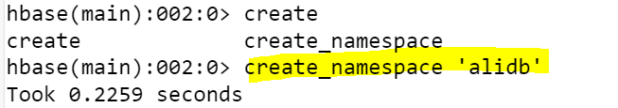

1. **Loading the data**

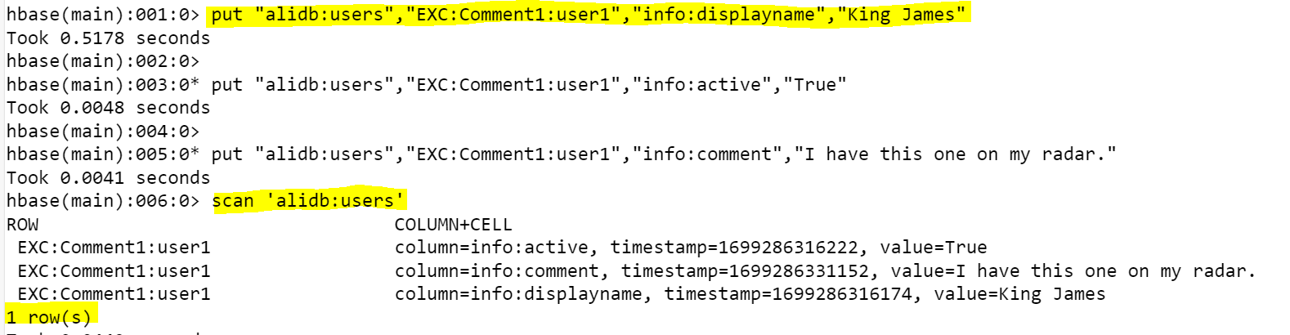

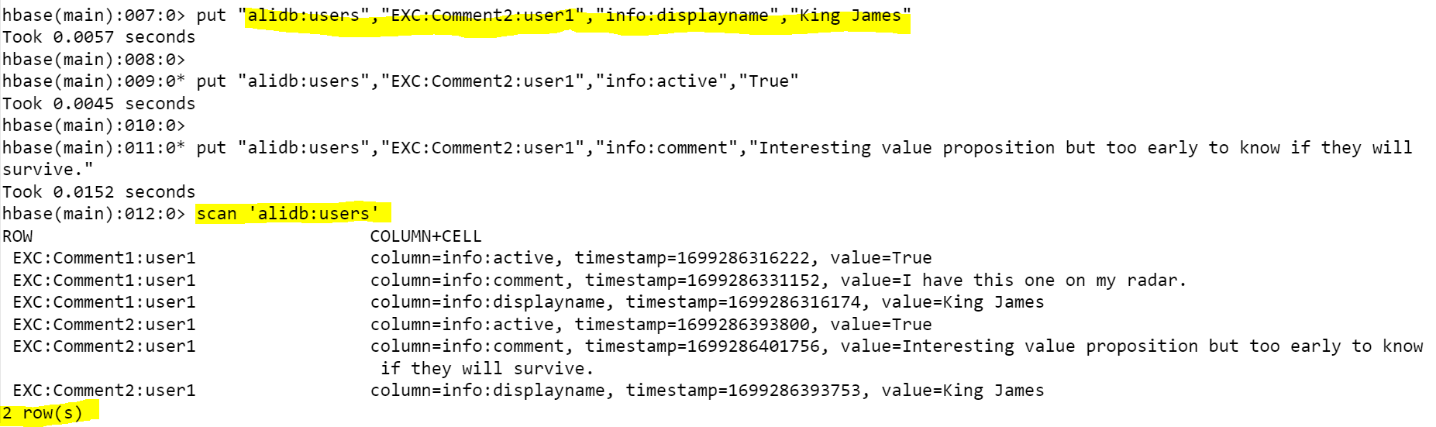

1. **What are the various comments given by all the users?**

1. **What are the comments by user3?**

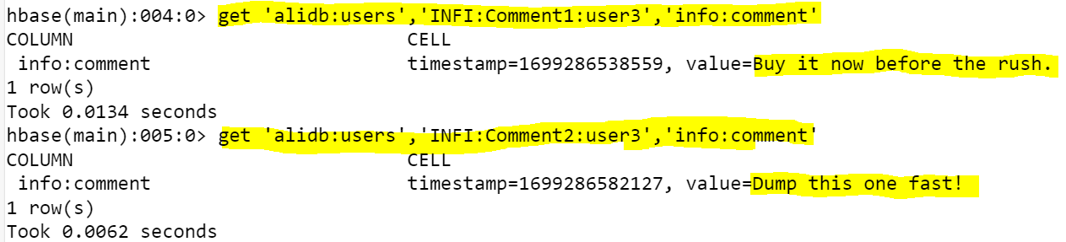

1. **Which users have inactive comments?**

